

**Course Code:** CSE3036.2

Final Lab Report

**Submitted To:**

**Submitted By:**

**Name** : Muntarin Islam

**ID: 2017000000045**

**Batch:**45

**Dept of CSE**

**Md.Mijanur Rahman**

**Lecturer,**

**Southeast University**

**Date of Submission: 24.08.2019**

**1.Task name: Create a folder**

* Command : pwd
* Description : View Current Folder
* Command: cd /c
* Description : Go to "C" directory
* Command : mkdir git
* Description : create a folder named "git"
* Command : cd git
* Description : change derectory to "git" folder

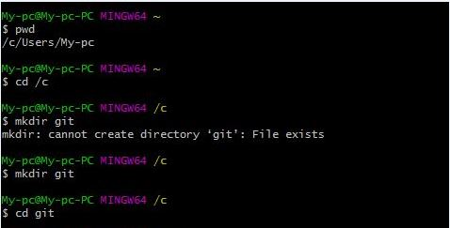

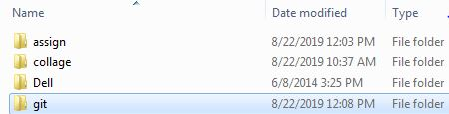

**2.Task name: add file in the folder**

* Command: nano something.txt
* Description: create a text file named "something.txt"

**C:\Users\My-pc\Pictures\4.JPG**

**C:\Users\My-pc\Pictures\3.JPG**

**3.Task name : delete file**

* Command: rm -r something.txt
* Description: Remove text file

**C:\Users\My-pc\Pictures\5.JPG**

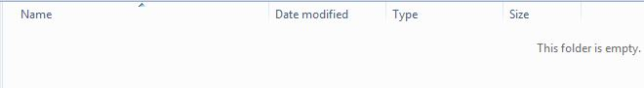

**4.Task name: delete folder**

* Command: rm -r git
* Description: Remove Folder named "git"

**C:\Users\My-pc\Pictures\7.JPG**

**5.Task name: Configure Git to Github**

* Command: git config --global user.name “Muntarin”
* Description: Configure Using User Name
* Command:git config --global user.email [muntarinislam424@gmail.com](mailto:muntarinislam424@gmail.com)
* Description: Configure Using Email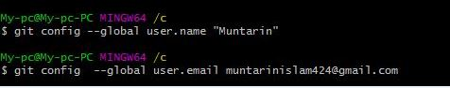

**6.Task name: Download file from github using git**

* Command:git clone <https://github.com/Muntarin/assign.git>
* Description:cloning copies all files, including the actual repository.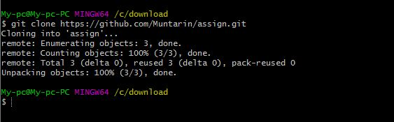

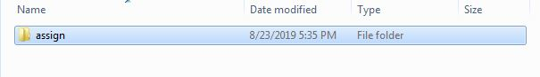

**7.Task name: create github repository and upload files on github using git**

* Command: echo "# assign” >> README.md
* Description: Make a file readme
* Command: git init
* Description: initialization git
* Command: git add readme.md
* Description: Initialized empty git repository in C
* Command: git add readme.md
* Description: adds a new file to staging. This file is now ready to be committed.
* Command: git commit -m “README.md"
* Description: commits new and updated files - moving them from the staging queue to your local repository.
* Command: git remote add origin <https://github.com/Muntarin/assign.git>
* Description:when you run git remote add origin <https://github.com/Muntarin/assign.git> ,then a new remote created named origin
* Command: git push -u origin master
* Description: gathers all the committed files from local repository and uploads them to a remote repository.  Put another way, this command syncs local repository and external repository so they are exactly the same.

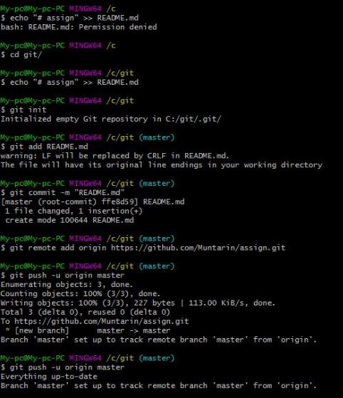

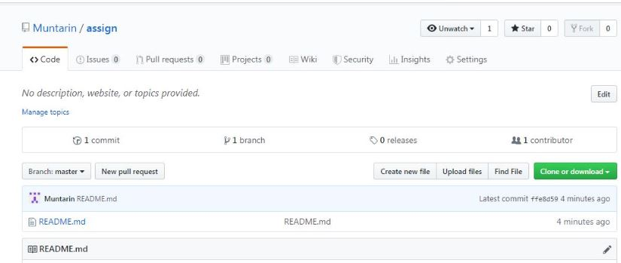

### 8. Task name:push an existing repository from the command line

### Command: git push –u origin master

### Description: git push is most commonly used to publish an upload local changes to a central repository.

### C:\Users\My-pc\Pictures\a.JPG

### 9.Task name: log

### Command: git log

* Description: git log is used to view the history of repository. Here we can see the local commits, along with the commit number, author info, date.

### C:\Users\My-pc\Pictures\log.JPG

### 10.Task name: Reset

### Command :git reset –hard ece85c0e7459bed991174b6f1b64cf90b1c61f66

### Description: By using the ‘reset’ command I completely discarded the changes from the last commit.

### C:\Users\My-pc\Pictures\reset.JPG

### 